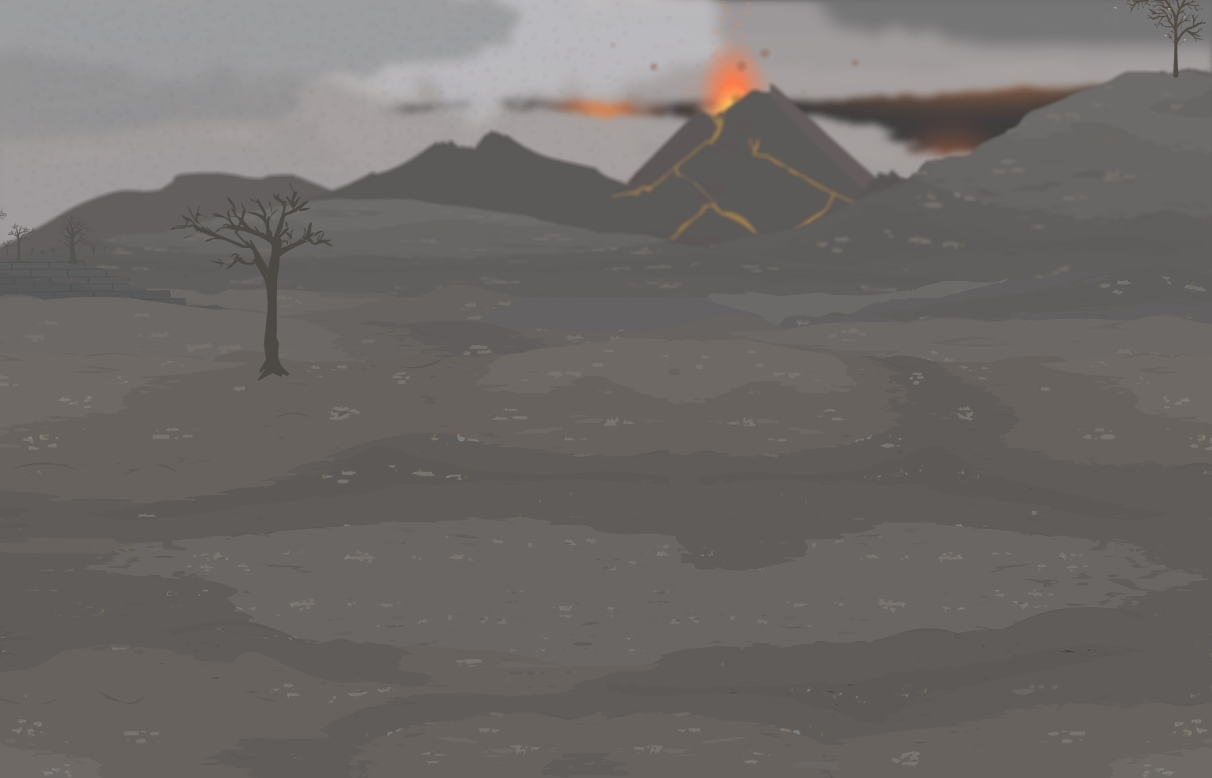
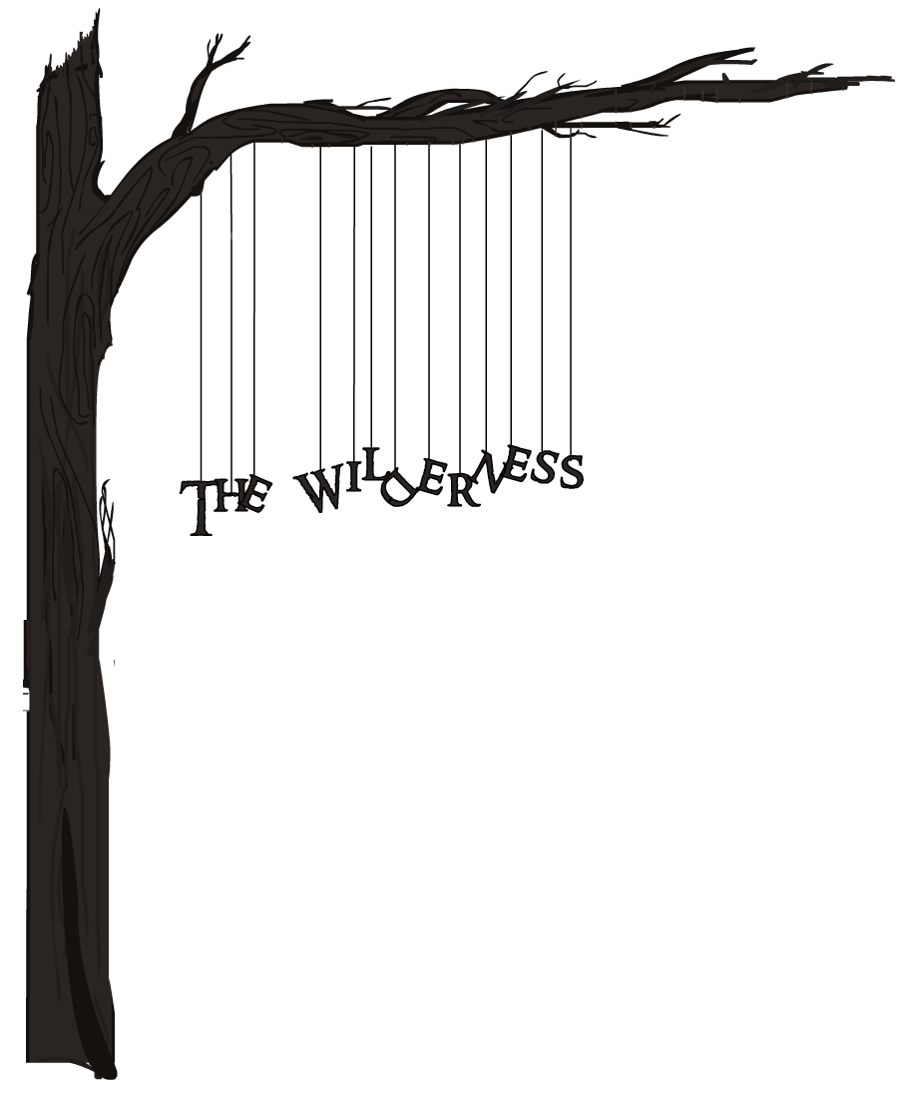

…an unauthorised biography
APPENDIX

CONTENTS
- Introduction: Runescape’s Greatest Threat [Page 3]
- The Food Chain [Page 7]
- Community Suggestions [Page 10]
- Existing Content [Page 11]
- New Content [Page 14]
- Systemic Changes
- Early exposure
- The Clan Wars Dilemma
- Synthesis of Ideas
- Conclusion

INTRODUCTION
Runescape’s Greatest Threat

2012. Runescape was popular as ever, with a player base so large that Jagex could not have fathomed it a half-decade before. We had just come out of “the year of clans” in which citadels, registration and member lists brought clans to new heights. Yet, for all the success afforded skilling, boss hunting and community clans, the PK clans of Runescape were still in rapid decline, our ultimate demise now imminent. It was then that we decided to record our story.
It began as a small project, a chronicle of our legacy. We, the members of the PKing clan community, had begun work on a video that would allow us to live on, if only in memory. As we pieced together our story, it became clearer by the moment that we the PKing community were merely pawns, and at the mercy of Jagex to save or sacrifice. The life force, the perceived power we thought was ours, was subject to whim of a Jagex update. In this knowledge, the biography of the wilderness changed. No longer was it a eulogy, but a cry for help. Our future was not ours to determine, but yours.
It was not your fault, Jagex, that we have fallen into ruin. The choice you made to remove the wilderness was necessary, and you are working for a greater good. We, the PKers of Runescape comprise a minority in the Runescape player base… but recall that it wasn’t always this way…

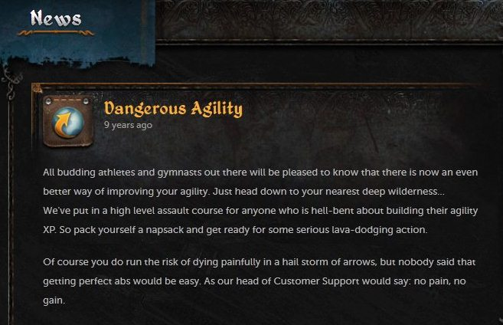
2003
a
shift
in values

2012
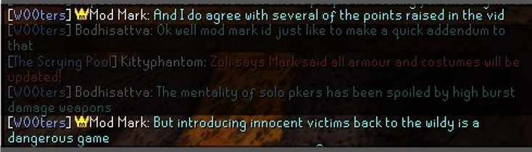

Player-killing was slowly phased out of popularity. As one would expect, an old generation of PKers was replaced by one that found contentment in such things as skilling, mini-games and quests - the central focus of a new Runescape. Some in Jagex may argue that these aspects are not replacing the popularity of PKing, but merely balancing the game to accommodate all. This is simply not true; if PKing was still popular, the PKing community would not be facing total collapse.
There is currently no concern more urgent than the revival of the wilderness. This document has been compiled on the eve of a major change in Runescape - the combat rework. We the PKing clans have put it to the test, and despite our disagreements over its strengths and weaknesses, we are unanimously agreed that while it helps, alone it is not enough to restore PKing to popularity.
The wilderness is the heart and soul of PKing, and excepting some graphic updates it has remained largely abandoned for many years. As it becomes less relevant (refer to the chapter entitled “The Food Chain” for further insight), the population of PKers continues to decrease. Such neglect has lost the player base hundreds of thousands of players. Should life be restored to the wilderness, the game would witness a dramatic rise in players, many of these coming out of retirement. If the wilderness continues to lose popularity, many thousands more PKers will leave the game. Since the release of the Wilderness Biography, dozens of clans have closed, and those remaining have shrunk to alarming sizes. We do not have the luxury of time on our side. If immediate action is not taken, our size and influence will diminish, and beyond a certain point the damage becomes irreparable.
In comparison to the extinction of an entire breed of hundreds of thousands of players, updates such as quests, make-overs and skill adjustments seem trivial. Such updates are luxuries, whereas the wilderness crisis presents urgent need.

This appendix represents the input of many hundreds of players. It is intended for use as a supplement to the original movie, which can be found here:

http://www.youtube.com/watch?v=kU8-mtY5ZKg

The chapter entitled “The Food Chain” is a detailed explanation of the mechanics of the wilderness. It explains what made the wilderness so popular in the first place, and why this is no longer the case.
Up until a few years ago the wilderness was the most important area of the game for a majority of players. The majority of players joining clans these days are more concerned with finding players to skill with or kill monsters with and are not about going into the wilderness and fighting with and competing against other traditional clans.

There is still a good shell and some great clans around, but on a much smaller scale, and there is very little competition compared to a few years ago. The PKing side of the clan world is likely to continue to shrink if the wilderness is ignored.

The suggestions following were distinctly formulated to combat the problems presented. Some are more detailed than others and vary in complexity and impact. It is not required for all these suggestions to be implemented. They are merely a point of departure; Jagex knows the game better than its player base, and so we present these suggestions only to inspire you. It is important to note, however, that the PKing clan world is in a dire situation and requires more than a light touch in order to survive. We urge Jagex to compensate for years of unintended neglect.

Following the suggestions is a look at the dilemma created by the clan wars arena and its tendency to replace the wilderness in many regards. The penultimate chapter, “Synthesis of ideas” is a reflection on the ideas presented and offers some ways in which they can be introduced. This is followed by a few concluding thoughts.
- Icedrop
Honourary Ex-Leader of Runescape Dinasty
RSD has won the Jagex Clan Cup (Combat) two years running

Interspersed throughout this appendix are quotes from influential figures in the wilderness scene.

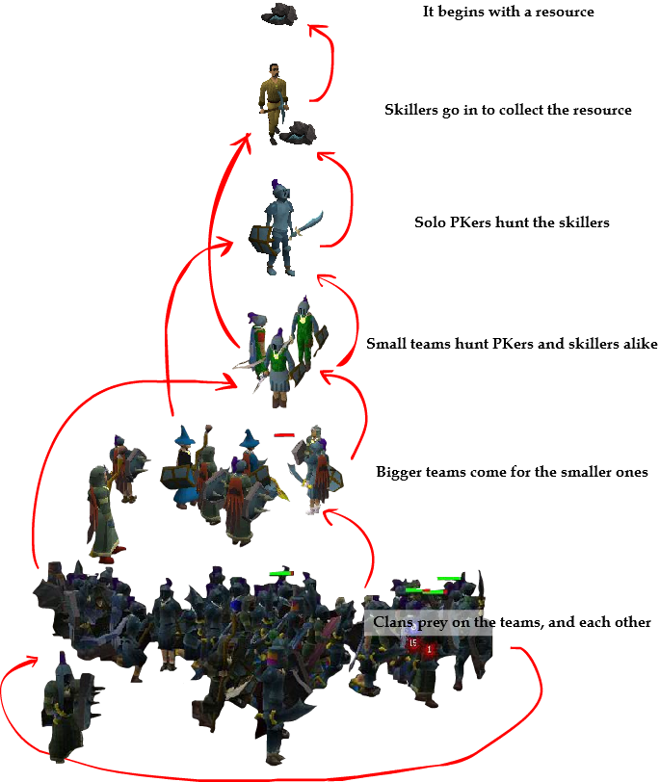

Figure 1

THE FOOD CHAIN

Men were made to hunt and gather. We did it ten thousand years ago, and even now we hunt and gather every day of our lives. Some go fishing, or collect things. Others chase women they admire. Thousands more stalk their prey in video games. It is pure instinct driving us to do such things.

In Runescape, there are gatherers - those who collect items and accumulate wealth - and hunters, who kill other players.

It is in the union of both that the success of Runescape is based. To deny one or the other spells disaster.

- His_Lordship
Leader of the Wilderness Guardians
WG is Jagex’s most endorsed clan

It is historically proven that wilderness activity depends on the abundance of a resource. One of the best examples is shown in Figure 1. The rune rocks once attracted miners of all persuasions. They were hunted by solo PKers (who had a 50/50 chance of killing them, depending on their skill), and the solo PKers in turn were bait for teams and so on.
As rune mining and smithing became less profitable after 2006, rune miners were seen only infrequently, and those who did continue to venture into the wilderness were safe – rune ore was no longer worth killing for. In 2012, the rune rocks are now void of life.
The pattern is recurring:
- The greater demons were once good monsters for training, with good loot.
- The spells acquired from the mage arena were once powerful and useful.
- The ancient portals were often used by players to take shortcuts.
- Noobs could make money collecting runes in the Dark Warriors’ Fortress.
- The chest in the lava maze once yielded a great profit.
- More recently, EP gains were a good source of money-making.
These days, there is but a single resource worthy of harvest – the revenants. It is the last bastion of activity, though even this place has its own problems. With the ability to teleport from combat and easily escape, the food chain is broken. No solo PKer or small team could profit here. Usually it takes a clan to take down an opponent, and even then, the profits are marginal because the victims keep their most valuable items. The situation is worse in free-to-play, which lacks any attractive resource.

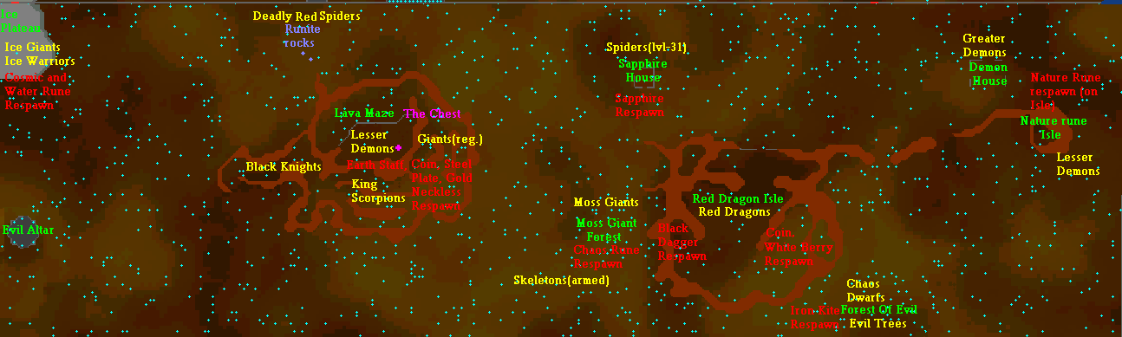
The wilderness has virtually retained the same form since it was first released in 2002, and has not evolved with the rest of the game. Eg. Monsters that once presented real threats are now common pests.
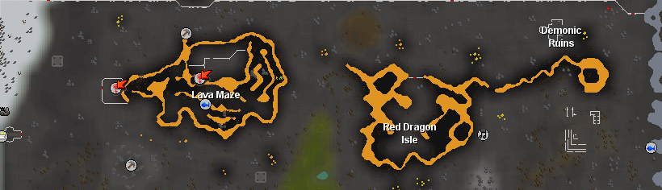
We believe the reason Jagex has been so reluctant to touch the wilderness is because PKing is player-driven gameplay unlike the rest of the game. The wilderness has always contained nothing but resources, and very little in the way of truly supporting PKing. The entire food chain was created by the players. In other words, this part of the map was handed over to us to do as we pleased. From this launching point, PKers and clans created an empire that spawned member lists, forums and even unwritten codes of honour that were held together by trust.
Let it be made clear that these proposals are not designed to “lure innocent players into the wilderness to die”. These players will have as much to gain from the wilderness as the PKers do. Entering the wilderness is optional. Those players who take the risk will be rewarded accordingly. We the PKers understand that our livelihood depends on theirs. These suggestions have been very carefully tailored so that every link in the chain (from skillers through to clans) will benefit in some form.
The suggestions outlined in this appendix predominantly target the resource component of the food chain, though a few vary from this.
Please take the suggestions seriously. Our experience in the wilderness is unrivalled; we know it better than Jagex.
This system worked well, until players stopped entering to harvest resources. It is not possible for PKing to exist without the first link in the food chain, in the same way life on Earth cannot exist without the sun. For the last twelve months, wilderness clans and teams have tried sustaining activity, but to no avail.

While the blood trees may have been an attempt at helping, it's not enough because there's no reason for people to stay there for more than a couple of minutes. The bolts are a novelty to PKing, not a staple. When everyone used rune, the rune ores were in the wilderness - they were a unique quality to the wilderness and people had good reason to go out there and to stay out there.
SUGGESTIONS
Below are many suggestions that the community believes will restore vitality to the wilderness. The suggestions are still relevant in light of the impending combat update, which we the community believe will not impact PKing positively enough to trigger the changes needed.
The beauty of these suggestions is that they are varied. Surely at least a few of them will take your fancy. While many dozens of suggestions were put forward, these were chosen on their perceived effectiveness by the community.
As these are still early days for the new combat system, we have limited the combat-related suggestions, and instead decided to focus on resources.

- Doug_Numbers
Member of The Gladiatorz
The Gladiatorz are one of Runescape’s oldest clans

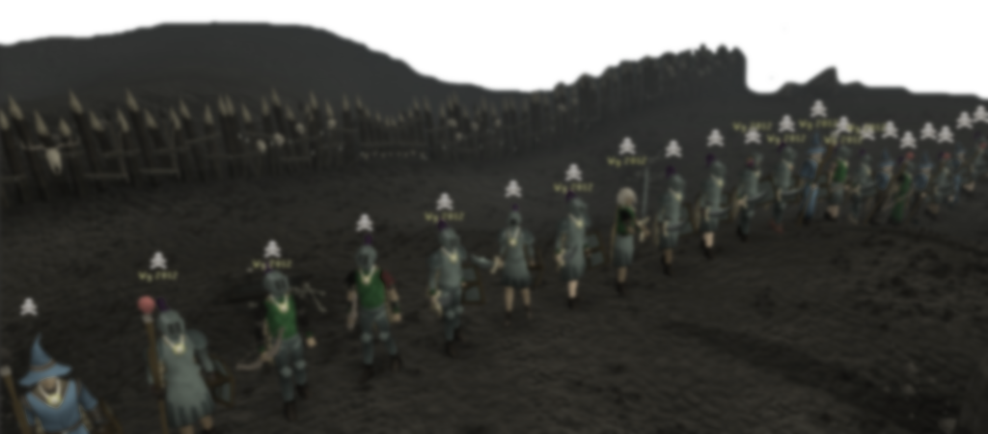

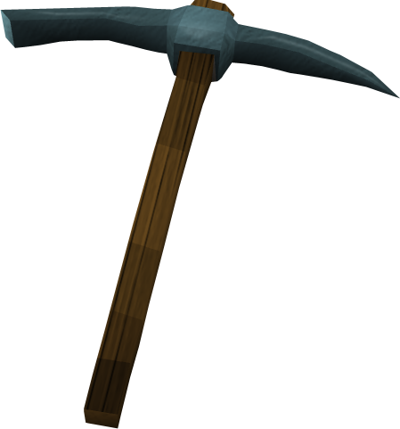
ADJUSTMENTS TO EXISTING CONTENT
Add more rune rocks to the current location. Five spawns in the wilderness should make it appealing. Other mines should offer bonus experience. It has also been suggested many times that dragon ore be made available to mine in the wilderness. Such ore could not be smithed by players (because players can only complete rune at 99), but could perhaps be given to an NPC to make weapons and armour.
The beauty of this suggestion is its simplicity. Vast changes can be accomplished with very little programming. It is suggested that these changes are rolled out in free-to-play wilderness, where the vast majority of clan PKing occurs.
These suggestions will increase the reward for players who choose to venture into the wilderness. However, these players should only benefit from increased experience gains and wealth if they themselves are risking valuable items. These updates would be pointless if such players were not attractive targets for PKers.
These proposals are quite conservative so that there is minimal impact on the Runescape economy, because most of these suggestions are aimed at low-levelled players. If low levels enter the wilderness, they will be hunted by medium-level players who will in turn be hunted by high level players. This is another aspect to the food chain. Common sense tells us that if the wilderness is to thrive, PKing must become enticing and profitable early in one’s career. Most new players these days are dissuaded from PKing, and once their playing styles have been established, it becomes much harder to change them later.
These suggestions also require players to stay in the wilderness for an extended period of time. If they are to become hotspots, PKers must be confident that they can find action in these places. PKers and clans tend not to camp in an area waiting for prey as this is not profitable nor is it enjoyable. Instead, they roam between locations. It is up to skillers, then, to provide the grounding.

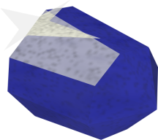

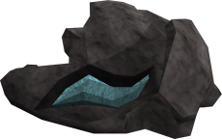

Change the sapphire spawn at spider hill to diamond in F2P and possibly have a dragonstone spawn in P2P. At current prices, a 16.5k spawn might entice a F2P player to go there for profit. With a steady demand for dragonstone jewelry, a 26.6k spawn won't really hurt the economy. Better yet, consider a random spawn every 10 minutes from an item pool - (items ranging from a DDS to Dragon Claws)
An increased amount of rune spawns in the dark warrior fortress and in deep wilderness. One rune isn't cutting it. A spawn of 20-50 chaos, natures, deaths and blood runes might entice someone to go out and gather.

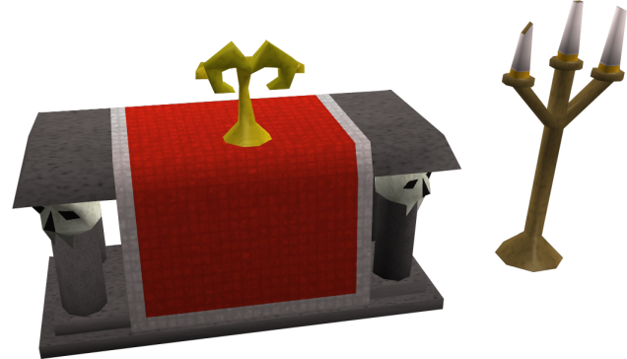

Offering bones to the low-wilderness Chaos altar would yield 225% normal prayer experience, and 275% experience for the deep one, even in free-to-play.
The furnace and the anvil at the ‘Ruins’ could offer a small experience boost, maybe 5%. It would stack with brawlers/sacred clay equipment/etc.
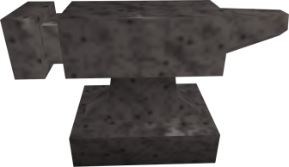
Give the greater demons (and many other creatures for that matter) a 150% bonus experience gain whilst killing them in the wilderness. In P2P, allow them to occasionally drop brawlers. There is also the possibility of replacing greater demons with a different monster with better training benefits.

Jagex, I think you've gone a bit soft and think we'll rage quit your game if we lose a rune axe in the wild. Well... everyone's just leaving out of pure boredom actually.

- Cornchips
Clanless, skiller

The Red dragons at the Red Dragon Isle should drop 1-3 red dragon hides. There should be a rare drop for these dragons. Perhaps they could drop Dragon Trimmings which could be used to upgrade the stats of dragon armour via smithing to rival the Barrows armours.
Have a rare drop for the chaos elemental that is worth collecting. At present, the chaos elemental is an unattractive boss to hunt. This will be particularly beneficial to boss hunting clans. The chaos elemental would be a good tool to encourage such clans to branch into PKing.

The muddy chest in the lava maze should offer a much greater reward.
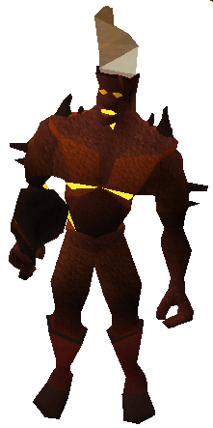

The fire giant dungeon in deep wilderness (near the mage bank) should have different creatures with better drops or experience. One good suggestion is additional charms gained from this dungeon.
Rogues in deep wilderness should offer better thieving experience and/or better loot.

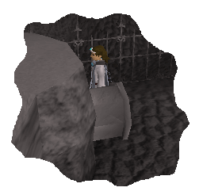
Update the abyss Runecrafting system so that it is once again competitive with ZMI.
The wilderness agility area should give more agility experience. Perhaps redesign it to fit better into the barren wasteland.

Increase the drop rate of brawlers. This kills two birds with one stone. Firstly, it will popularise the revenant dungeon, and second, it will encourage people to skill elsewhere in the wilderness.
Monsters killed at the volcanic crater while on a Slayer Task give bonus slayer experience, maybe also combat experience.

NEW CONTENT

The proposals put forward in this suggestion will add new material to the wilderness rather than build on what already exists. As one would expect, the wish list becomes more ambitious from this point forward.
Some of these suggestions require more time and effort than others, but we believe that all will be effective.
One very important request that we make to Jagex in this section is to offer a significant number of these resources to free-to-play wilderness, for three reasons:
1. Free-to-play wilderness, unlike its member counterpart, is completely void of attractive resources for high and low levelled players.
Areas of intense volcanic activity that are so hot that ore can be smelted at them without coal. These should be located near Ancient Teleport destinations, closer to higher deeper destinations than lower ones. They should also be located near the Hobgoblin mine, rune rocks, and Pirate's Hideout mine.
The volcano in the north east corner of the wilderness (Lv50) - Lava rising from underground and spilling out onto the surface leaves behind mineral rich deposits including adamantite, runite, higher class gems (rubies/diamonds/dragonstones) and perhaps a new ore which can be smithed into materials used to repair and maintain PvP equipment or forge tradable and degradable tools which produce bonus experience when used in the wilderness (these could also be repairable).
2. Most PKing clans prefer to fight in free-to-play wilderness. This has been the case since the release of Runescape 2, and is unlikely to change as a result of the combat update. If there are no skillers in free-to-play wilderness, the food chain will collapse.
3. As all players begin their careers in free-to-play, they should be encouraged to enter the wilderness early on so that they may join the world of PKing from the very beginning.
Add grenwalls or red chinchompa hunter spots, or improve experience gains for hunting black salamanders.
We do not expect you to roll out all of the following changes, but we are hoping for the highest possible number you can provide.

At the very north of the wilderness the entire coast could be covered in fishing spots which can appear anywhere along the cost. They would yield a new high-level fish caught using tradable bait obtained from zombies in the wilderness, something with the appearance and name fitting the hostile nature of its location. It would offer the same healing as rocktails + half your constitution level (5-50), therefore it would heal between 235-280LP. However it would not boost you past your max life-points or be stackable with a potion.

Mobile Resources
Mobile resources would spawn in a random fashion all over the map. They should stay for a decent period, maybe 15-20 minutes (it shouldn't be an exact time). While there would be a chance to find them practically anywhere in the Wilderness (or wherever Jagex can program the spawns), resources would be found more commonly and in better qualities in higher levels of the Wilderness. All of these resources would require a skill level to harvest or process.
- Gem deposits - Deposits of Sapphire-Diamond gems
- Ore deposits - Deposits of Coal-Runite ore
- Red sandstone outcropping - A mound of Red sandstone. A thermal vent would spawn nearby where the sandstone could be converted to glass.
- Charmflutter flocks - Groups of creatures called Charmflutters, which turn into Summoning charms when caught. Intended to attract summoning tanks and summoning skillers. Range from gold to blue charmflutters.
- Decaying obelisk - A obelisk that is falling apart and can be mined for Spirit Shards.
- Stoutstaff tree - A tree whose branches can be crafted into Battlestaves.
- Ore flow - A rift full of flowing molten metal, which can be Gold, Silver, or Steel. Using the appropriate mould, you can make jewellery or cannonballs out of the metal.
- Molten glass flow - A pool of molten glass that can be blown into any glass object. Would be located near an elemental pool which can be used to power glass orbs without any runes.
- Demonic thorns - Thorn bushes that can be burnt down to harvest demon ashes from their remains.
- Overflowing pools - Pools of fish from Salmon-Rocktails that can be caught without bait and at accelerated rates. A thermal vent would spawn nearby to cook the fish in.
- Essence outcroppings and energy clusters - An outcropping of rune essence would spawn close to a small cluster of rune energy that can be used to craft runes at 1.5x the normal xp. Clusters can be of any energy, including Soul.
- Herb growth - Growths of herbs from Ranarr-Torstol.
- Decrepit structure - Crumbling structures that can be torn down to scavenge construction materials from their parts. Even a small chance of Magic stones at high level structures.
- Hardy tree - A tree from Willow-Magic that would be inexhaustible until it despawned. Also faster to collect from than normal trees.
- Infernal vent - Would be located near hardy tree, overflowing pool, and ore deposit locations. Fish, coal, and logs used on these would be utterly consumed quickly, yielding Firemaking XP (the same amount as given for gathering should work).

This figure is a reasonable estimate based on clan sizes in previous years and extensive feedback from retired players.

